1. Objective of the Experiment
This geometric optics lab follows the study of the prism using an instrument capable of measuring angles with high precision, called a goniometer.
This experiment also provides an opportunity to become familiar with the following aspects:
- The handling and adjustment of a precision instrument
- The phenomenon of light dispersion by a glass prism and the visualization of a discontinuous spectrum
- Finally, the measurement of the apex angle of a prism and the refractive index of the prism with respect to a given light radiation.

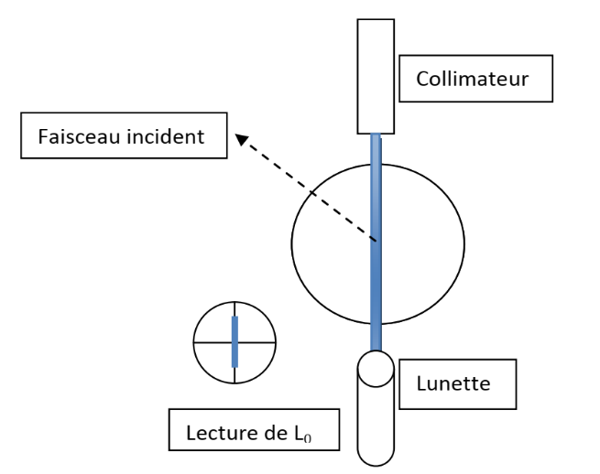
2. Measurement of the Goniometer Zero Reference
Incident beam
Collimator
Telescope
Reading of L₀
Figure 1
To determine the zero of the goniometers, the incident beam is directly sent toward the telescope by adjusting the width and sharpness of the light beam passing through the slit of the collimator.
Then, the observed spectral line is aligned with the vertical crosshair as shown in Figure1. The telescope is locked, and the adjustment is refined using the micrometric screw.
Obviously, the thinner the line, the more accurate the measurement. A reading is made in degrees on the graduated circle and in minutes on the vernier.
This value corresponds to the L₀ reading, or the zero reference of the goniometer.

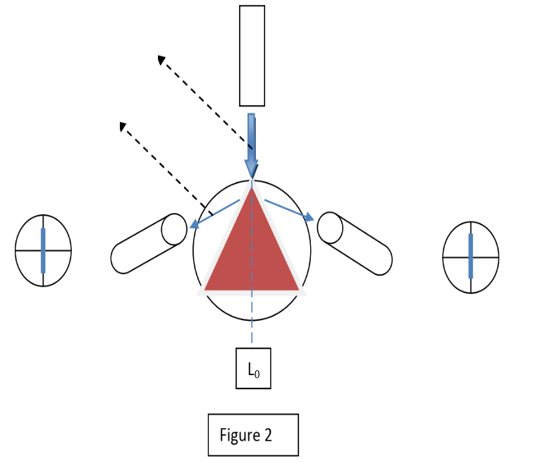
3. Determination of the Prism Apex Angle (A)
Figure 2
Reading of L₂
Reading of L₁
Incident beam
Reflection beam
Place the prism on the rotating table so that the edge of the prism coincides with the direction of the incident beam coming from the collimator (Figure 2).
Slowly move the telescope in the direction of the beam reflected by face 1.
Once the desired line appears in the telescope’s field of view, center it (align it with the vertical crosshair), lock the telescope in this position, and read the angle value in degrees and minutes. This corresponds to reading L₁. Repeat the same procedure for face 2 to locate the beam reflected by that face and record the corresponding value L₂.
The apex angle A of the prism (in degrees and minutes) is calculated using the following formula:
$A=\frac{∣L2-L1∣}{2}$

4. Determination of the Minimum Deviation
The procedure is as follows:
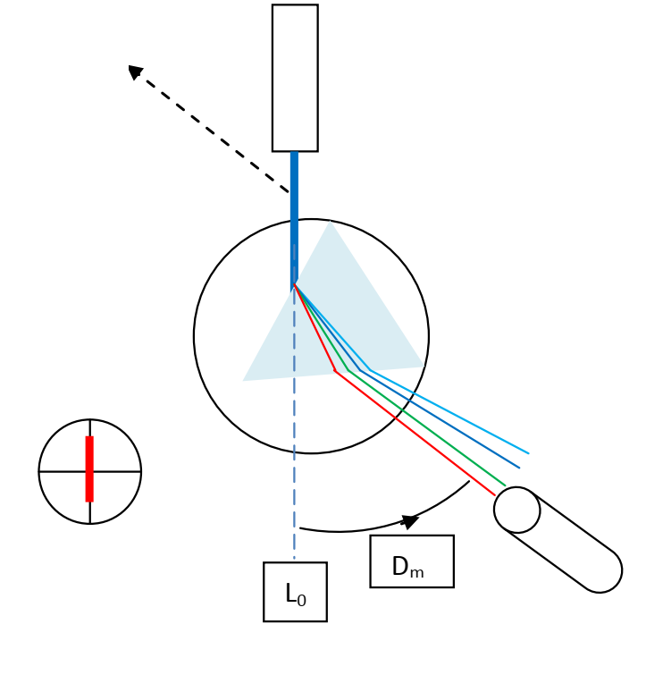
Place the prism on the support as shown in Figure 3. The prism will disperse the polychromatic light coming from the collimator into monochromatic radiations.
Once the spectrum of lines has been observed, gradually increase the angle of incidence by slowly rotating the prism table.
Incident beam
Reading of L_{m}
Figure 3
You will notice that the lines move in one direction where the deviation decreases, and upon reaching the critical incidence angle, they start moving in the opposite direction where the deviation increases.
The goal is to identify the point where the lines stop and reverse direction — this point corresponds to the minimum deviation.
Rotate the prism support until a spectrum of lines appears (red, green, violet-blue, and blue lines are visible).
Continue rotating and observing through the telescope: the spectrum should reverse direction, confirming the existence of a minimum deviation angle Dₘ.
Then, position the vertical crosshair at the center of the image for:
- the red line (for the cadmium lamp), or
- the orange line (for the zinc lamp).
Lock the telescope using the corresponding screw, fine-tune, if necessary, with the micrometric screw, and record the Lₘ reading.
The minimum deviation for the selected line is then calculated as:
$$D_{m}=∣L_{m}-L_{0}∣$$

5. Student’s Work
- Measure L₀, the zero of the goniometers.
- Measure L₁ and L₂, and deduce the apex angle A of the prism.
- Measure Lₘ, corresponding to the red line (cadmium lamp) or orange line (zinc lamp), and calculate the corresponding Dₘ value.
- Calculate the refractive index n of the prism for the red line (nᵣ) or for the orange line (nₒ).

